**Topic:**

Speed Dating analysis from Columbia University.

**Rationale:**

We were looking for an interesting and unusual dataset for this data analysis project. We determined that the speed dating data set is unusual and will assist us in conducting various analysis to better understand what influences individuals to determining if someone would be a good match. This dataset also presents a lot of opportunities for interesting and illuminating visualizations.

**Visual Inspiration:**

The Javascript challenge homework can be leveraged to provide the ability for the user to filter and/or group the dataset.   
  
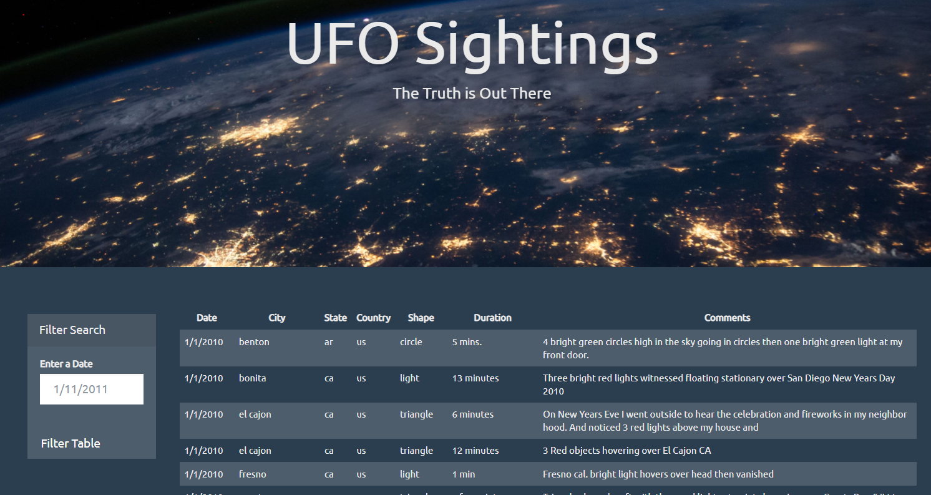

The D3 challenge homework provides a good example of how we can create a scatter plot for the speed dating participants. We can put different criterias along our X and Y’s and make it interactive so that a user can see correlations between the different variables.   
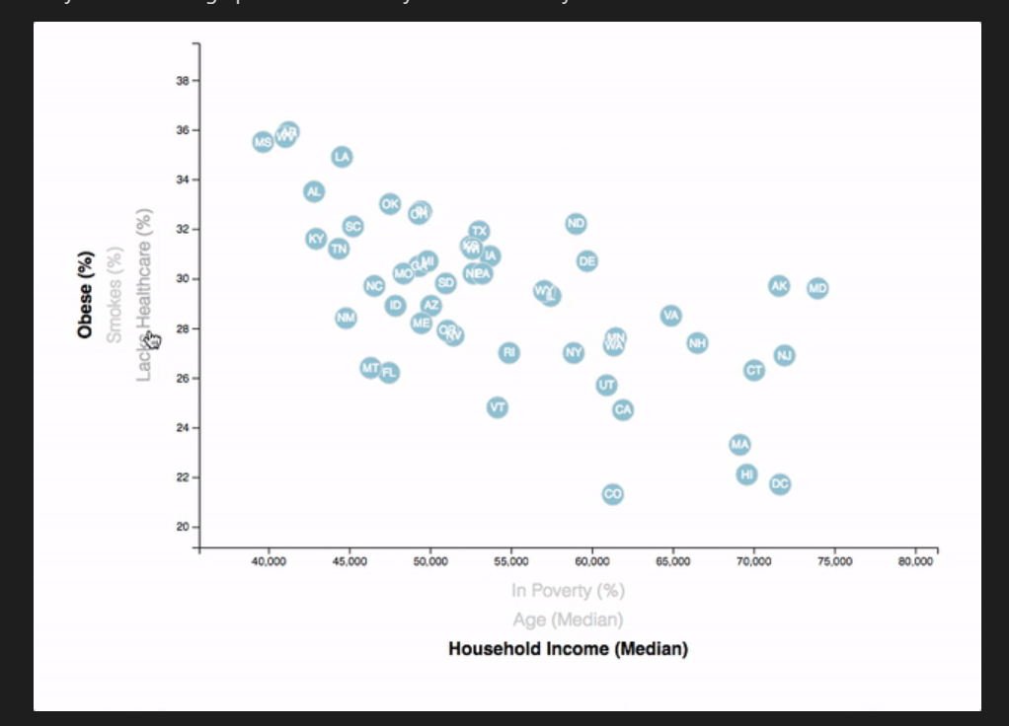

The Web Design challenge homework framework can be used to group different key correlations.

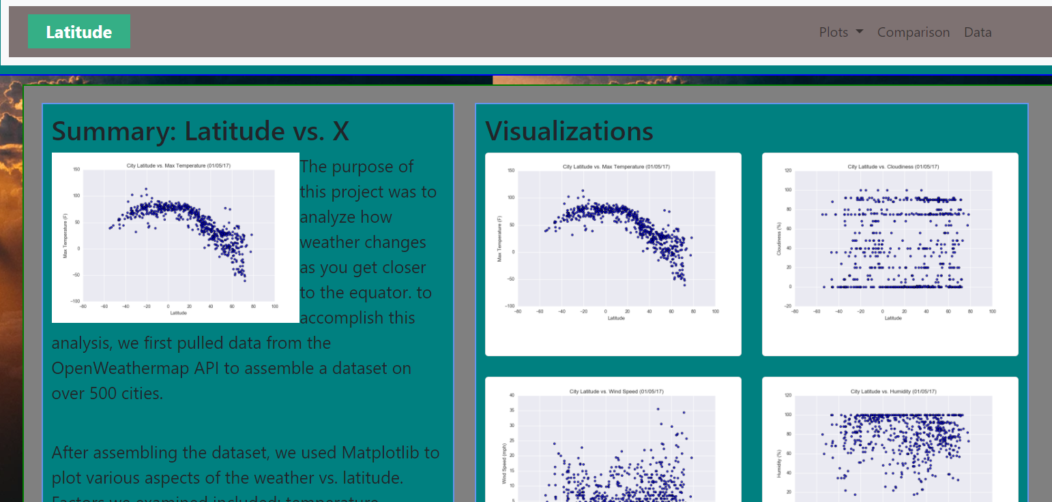

The Marker Cluster activity will help us create a map of the participants and their matches.

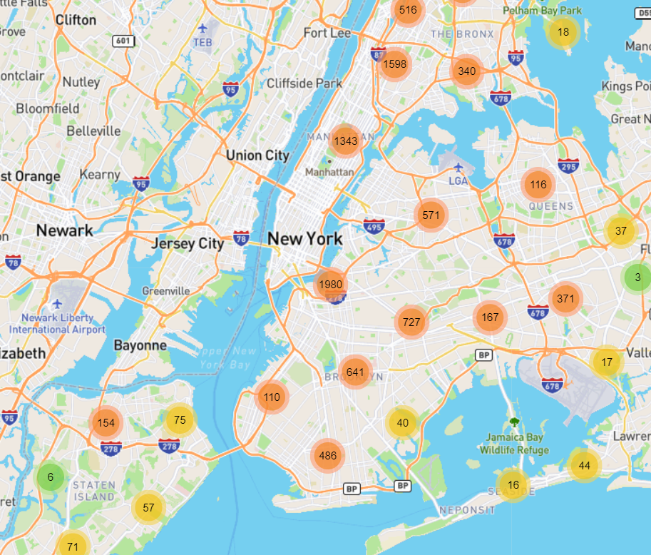

**Dataset:**

<http://www.stat.columbia.edu/~gelman/arm/examples/speed.dating/>



Explanation of columns:

<https://perso.telecom-paristech.fr/eagan/class/igr204/data/SpeedDatingKey.pdf>

Published Study: https://www0.gsb.columbia.edu/mygsb/faculty/research/pubfiles/867/fisman%20iyengar.pdf

**Architecture:**

